

Dr. Steven, Mcfarland inc.

2016-06-22

Dr. Mcfarland

17876 Kristin Well Apt. 642, Marvinburgh, GU 74760

Phone: 8209012088

Fax: 1086873308

**Re:** Erica, Daugherty

**PHN:** 4851284671

**Birthdate:** 25-Jul-2001

**Address:** 59275 John Shores, Nicolechester, MI 65758

**Patient number:** 6805710119

To Whom It May Concern:

This is a medical letter to state the above patient is pregnant with expected delivery date of 04-Mar-2025. Hoping this information is satisfactory for your requirements.

Thank you.

Sincerely,

Dr. Steven, Mcfarland

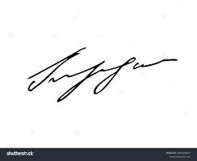

FRCS© NCMP

Clinical Assistant Professor, UBC

Department of Obstetrics and Gynecology SMH